COMPUTER NETWORKS

HOME TASK

TOPIC:
TOPOLIGIES

NAME:
MUHAMMAD TALHA
ROLL NUMBER:
241890
SECTION:
4/A

INSTRUCTOR:
SIR MUHAMMAD BILAL

TASK: Make topologies in packet tracer and provide connectivity:
- Point-to-point
Topology:
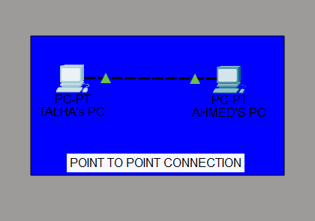
Connectivity:
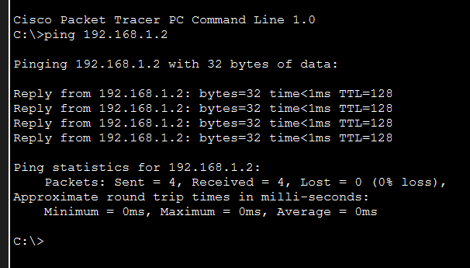
- Bus
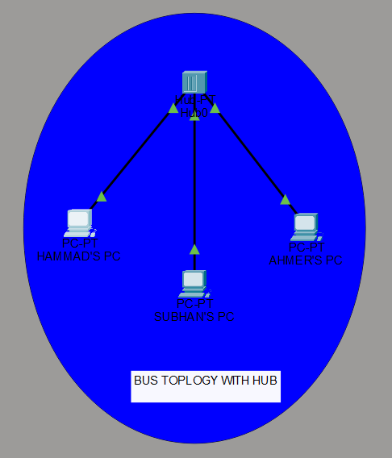
Topology:

Connections:
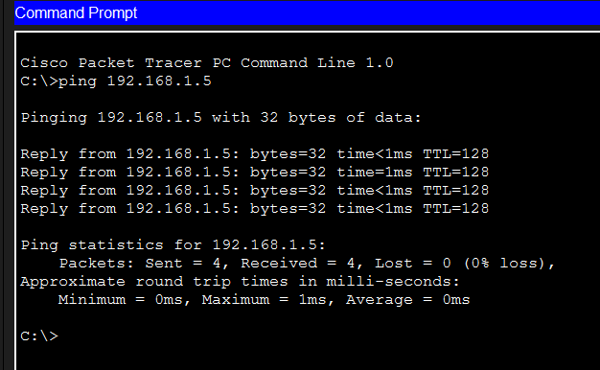
- Star
Topology:
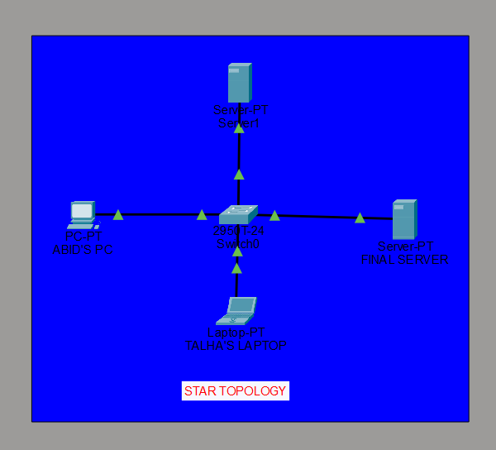
Connectivity:
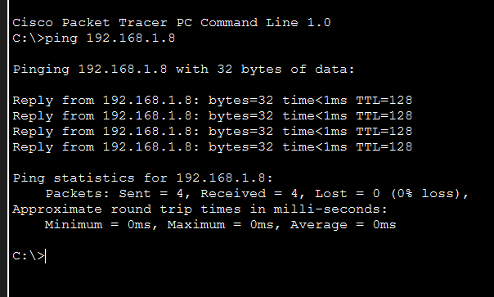

- Ring
Topology:
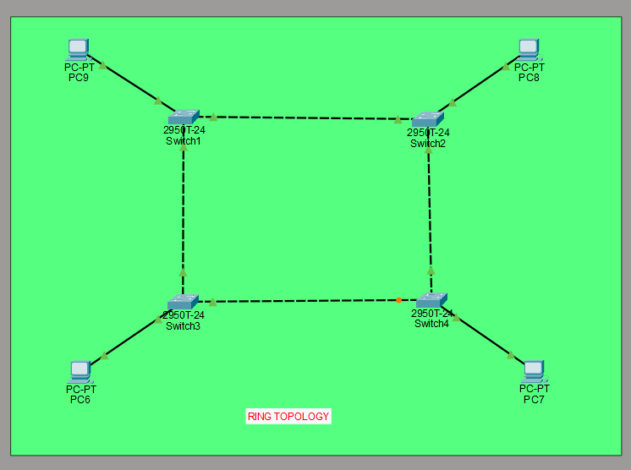
Connectivity:
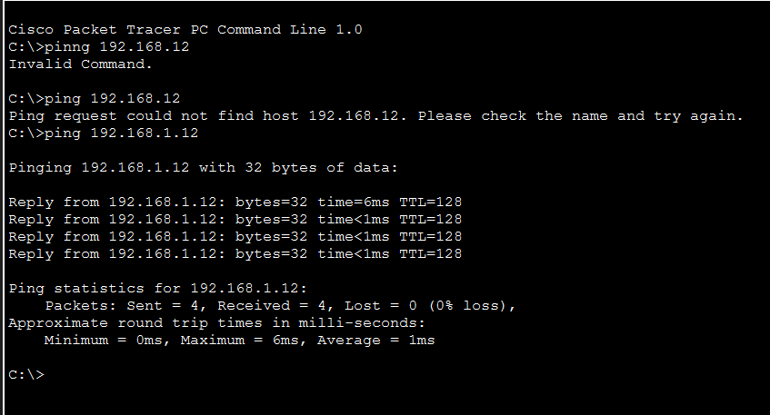

- Mesh
Topology:
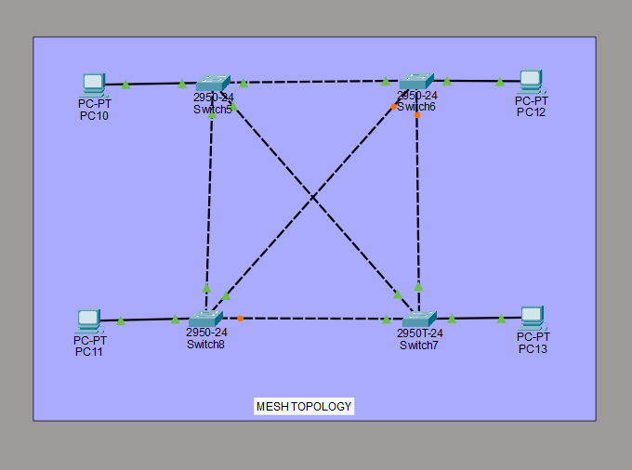
Connections:
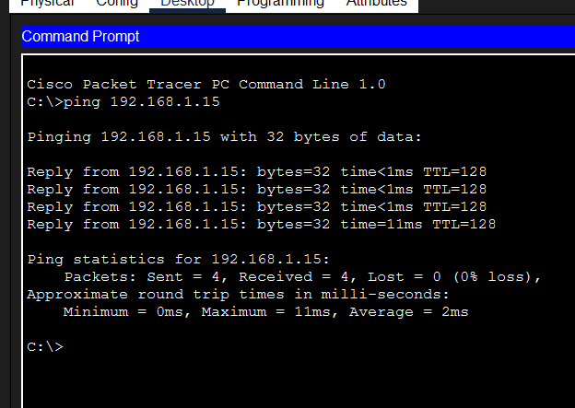

- Hybrid
Topology:
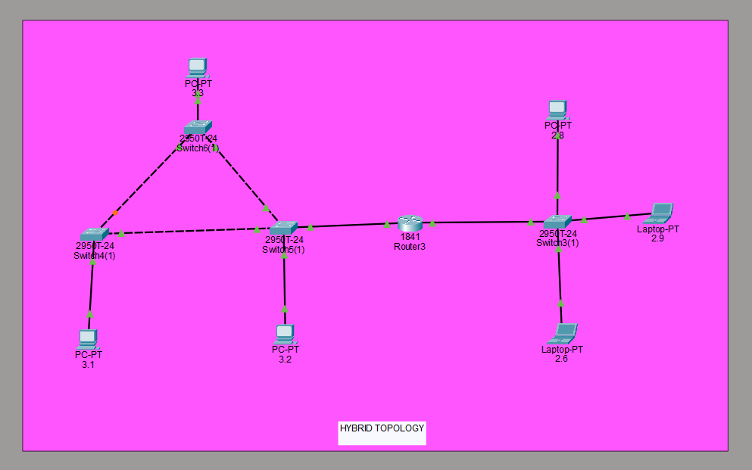
Connections:
